

**NET320-Database Systems**

**SWS213-Database Design**

**Spring ‘18**

# Lab 9- LAB ASSIGNMENT V3

*CLO2 Design and implement a database solution based on a given business scenario*

**Name:**

**ID:**

|  |  |  |  |  |
| --- | --- | --- | --- | --- |
| Task 1/ 10 | Task 2/ 10 | Task 3/10 | Task 4/10 | **Total /40** |
|  |  |  |  |  |

**Objective**

The objective of this lab is to create a complete database based on the below requirements.

Create an ER diagram

Create queries.

**Grades**

Grades are distributed based on Tasks

**Submission Details**

Students can submit the saved MySQl file to moodle.

Copy the ER diagram, queries to this word file and upload to moodle.

Last day of Submission 01/May/2018 at 6:00 PM

Below given is the one possible database state for the COMPANY relational database schema.

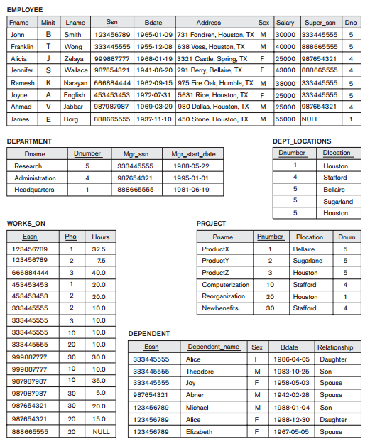

**Task 1**

Draw the Schema diagram for the COMPANY relational database schema

ANS:-

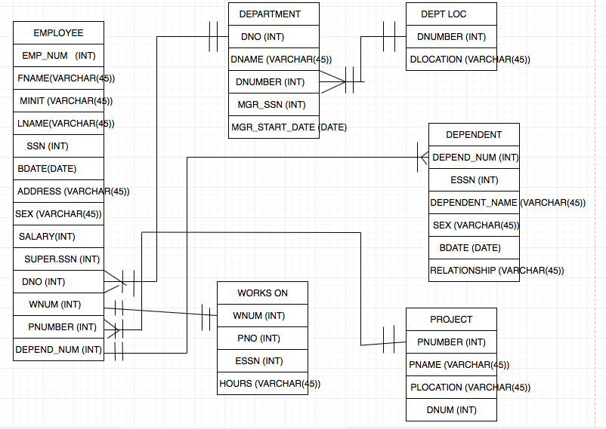

**Task 2-**

Create a DB. Students can use MySQL and Workbench to create the database. Students can use foreign keys and different attributes based on the situation. ( For Ex: In the EMPLOYEE relation, the attribute Dno refers to the department for which an employee works; hence, designate Dno to be a foreign key of EMPLOYEE referencing the DEPARTMENT relation.)

Save the file in your name and upload to moodle.

**Task 3**

Create an ER Diagram. Copy to the last page of the file.

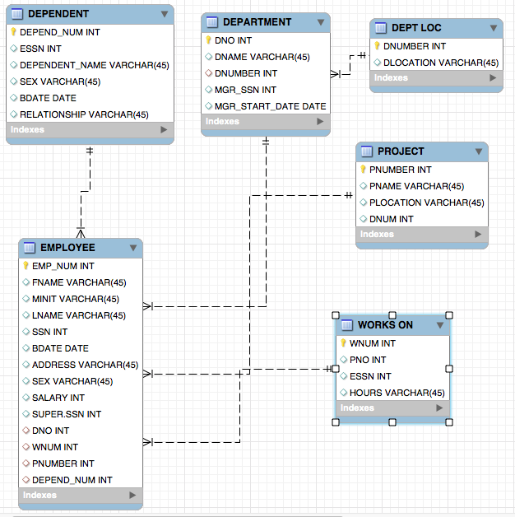

**Task 4- Queries**

1. For each employee, retrieve the employee’s first and last name and the first and last name of his or her immediate supervisor.

SELECT FNAME, LNAME, MGR_SSN FROM company.employee, company.department

WHERE employee.DNO = department.DNO;

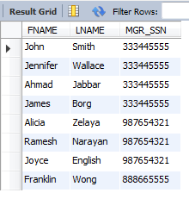

Now to find their supervisor’s names, we use the mgr_ssn values.

SELECT FNAME, LNAME FROM company.employee, company.department

WHERE employee.SSN = department.MGR_SSN;

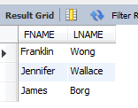

2. Retrieve the names of all employees in department 5 who work more than 10 hours per week on the ProductX project.

No results found for product X so I put instead Product Y.

SELECT FNAME, LNAME FROM company.project, company.employee, company.works_on, company.department

WHERE employee.PNUMBER = project.PNUMBER AND employee.WNUM = works_on.WNUM AND employee.DNO =

employee.DNO AND DNUMBER = 5 AND HOURS = '10.0' AND PNAME = 'ProductY';

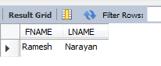

3. List the names of all employees who have a dependent with the same first name as themselves

There are no dependents with the same first name but I put a code to diplay all dependents:

SELECT FNAME, LNAME, DEPENDENT_NAME FROM company.employee, company.dependent

WHERE employee.DEPEND_NUM = dependent.DEPEND_NUM;

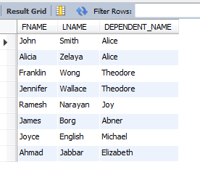

I APOLOGIZE SIR BUT YOUR VALUES HAVE NO NAMES THAT ARE EQUAL.

4. Make a list of all employees for projects that involved with a salary of 30000 or 25000 with the Research Department. *(Use -UNION, EXCEPT (difference), INTERSECT Corresponding multiset operations: UNION ALL, EXCEPT ALL, INTERSECT ALL)*

SELECT FNAME, LNAME FROM company.employee, company.project, company.department WHERE SALARY = 30000

UNION

SELECT FNAME, LNAME FROM company.employee, company.project, company.department WHERE SALARY = 25000;

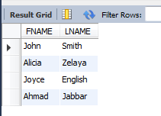

SELECT FNAME, LNAME FROM company.employee, company.project, company.department WHERE SALARY = 30000

UNION ALL

SELECT FNAME, LNAME FROM company.employee, company.project, company.department WHERE SALARY = 25000;

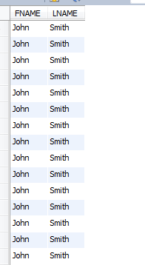

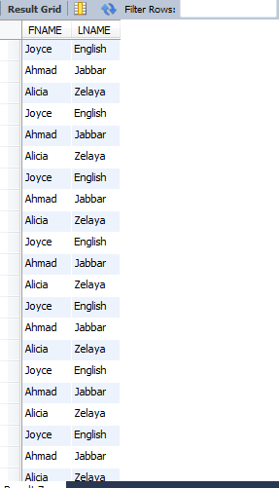

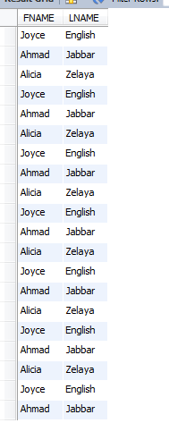

EXCEPT DIDN’T WORK. I TRIED 3 TIMES. SAME WITH INTERSECT





5. Retrieve the name and address of all employees who work for the Research Department.

SELECT FNAME, LNAME, ADDRESS FROM company.employee, company.department

WHERE employee.DNO = department.DNO AND DNAME = 'Research';

